Week-1 Logbook

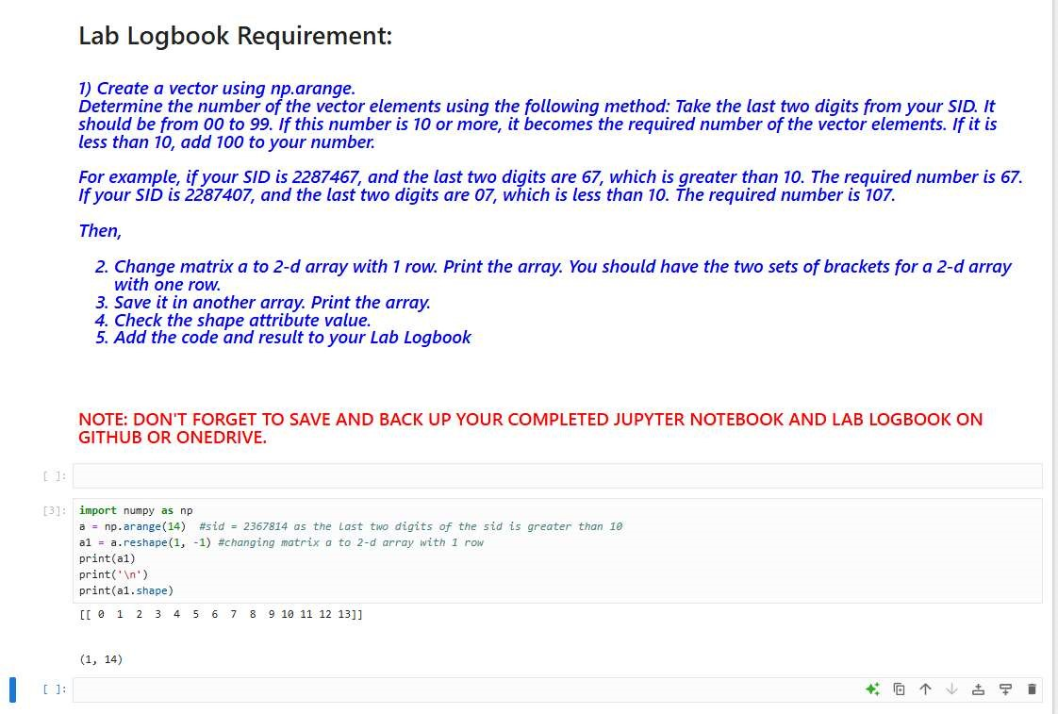

Week-2 LogbookD

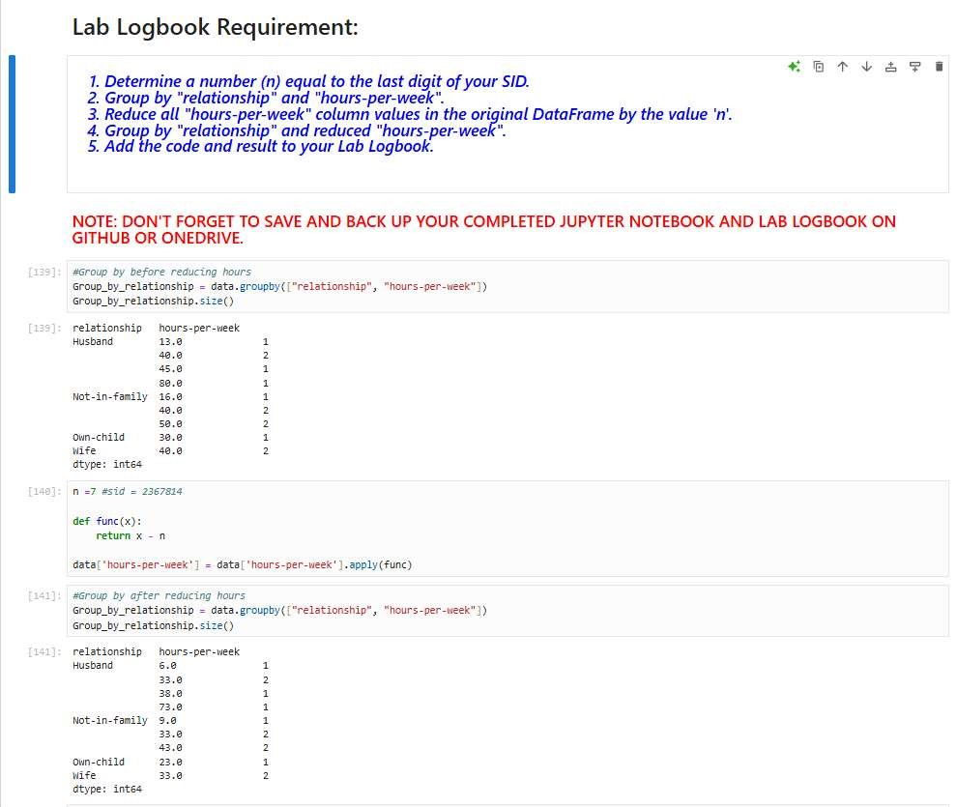

Week-3 Logbook:

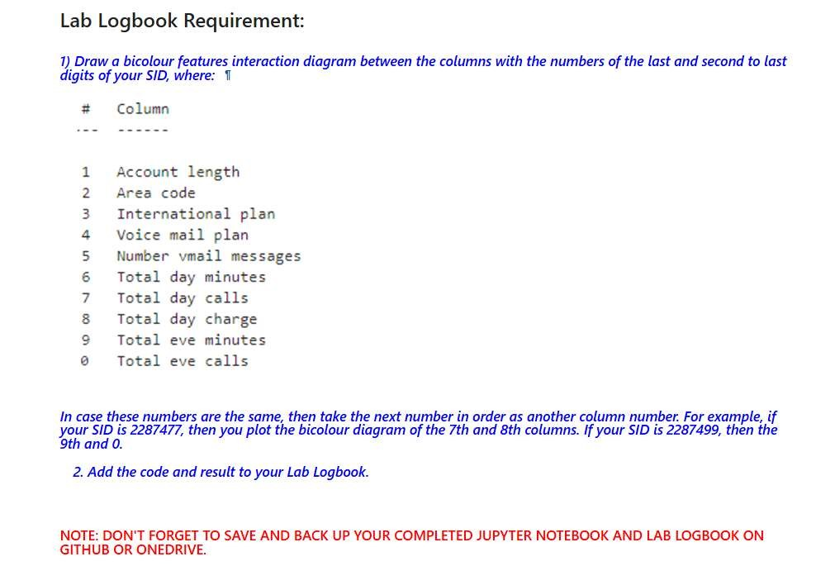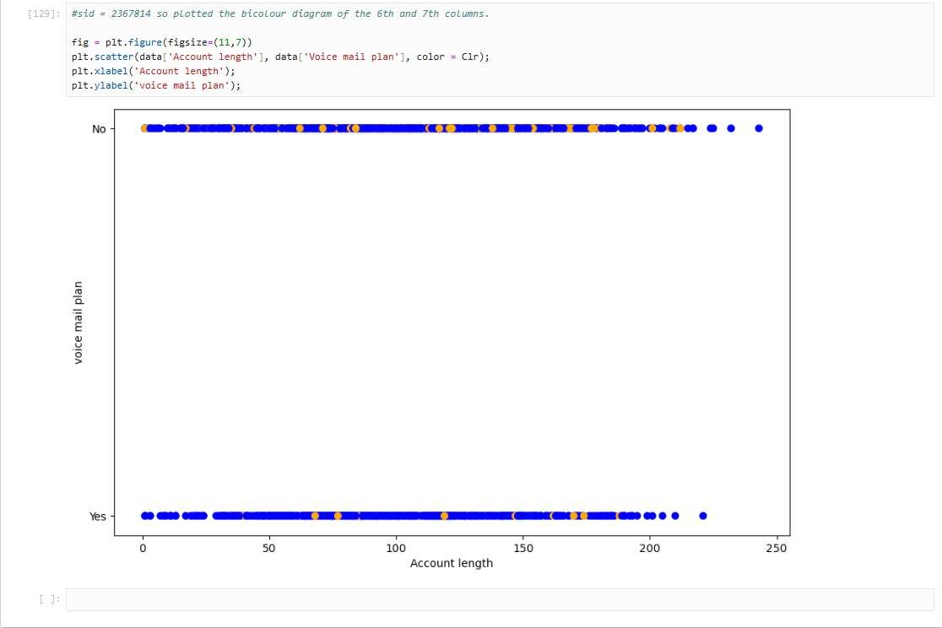

Week-4 Logbook:

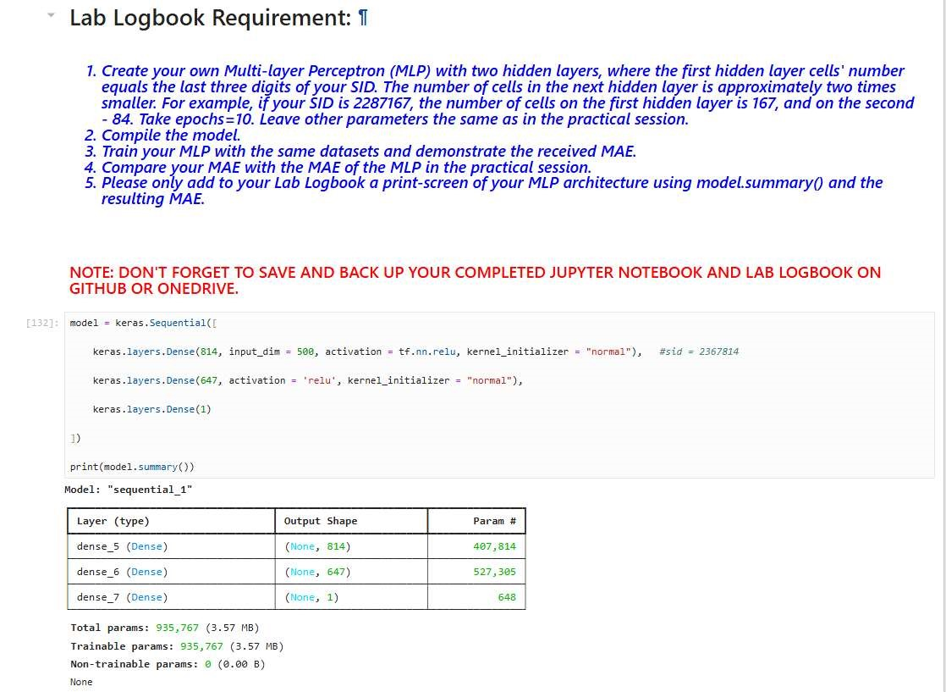

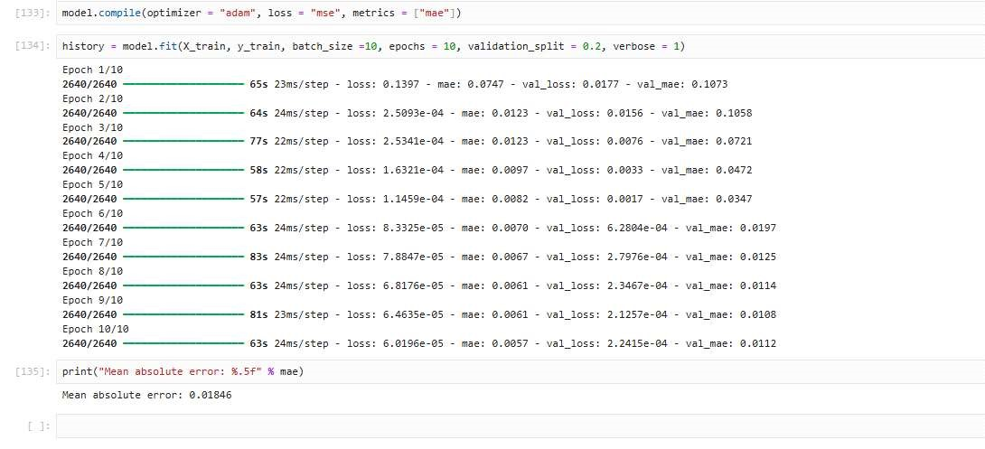

Week-5 Logbook:

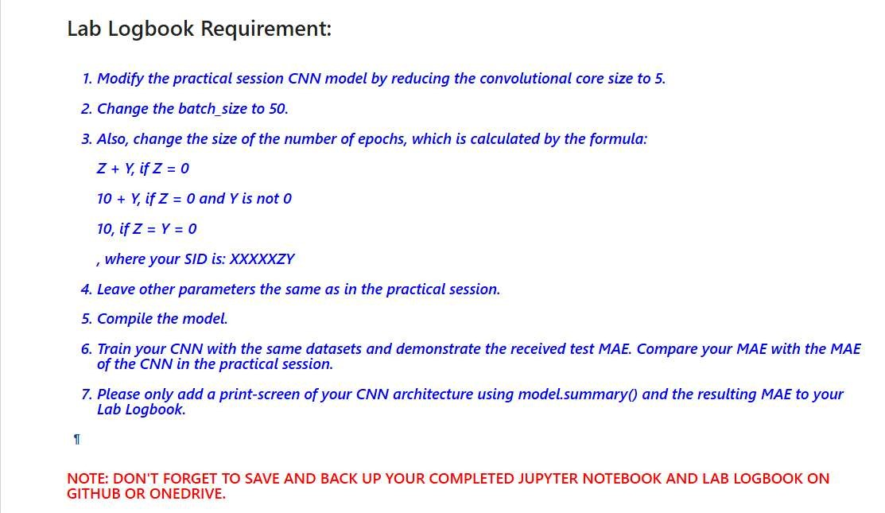

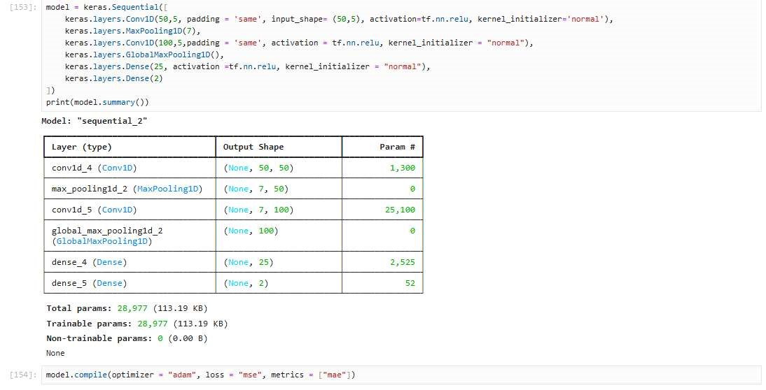

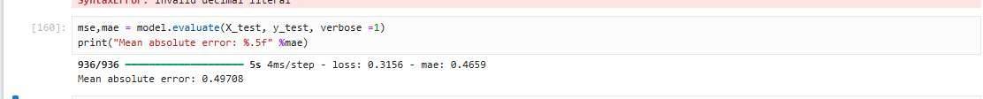

Week-6 Logbook

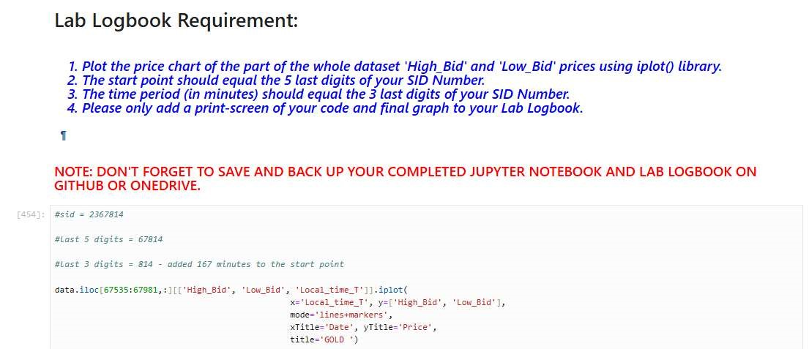

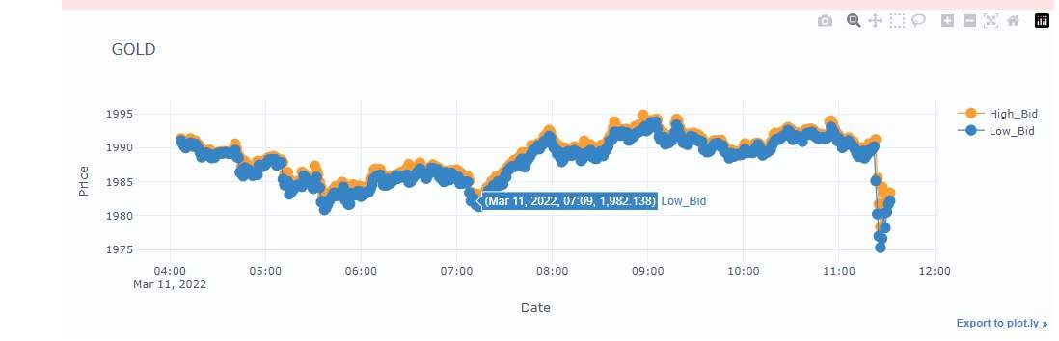

Week-7 Logbook:

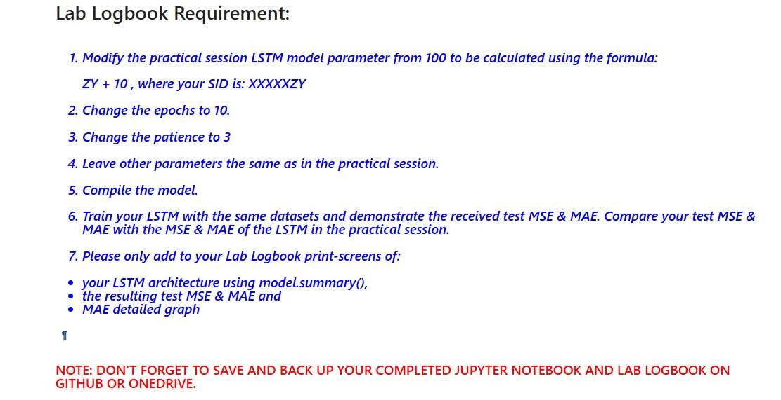

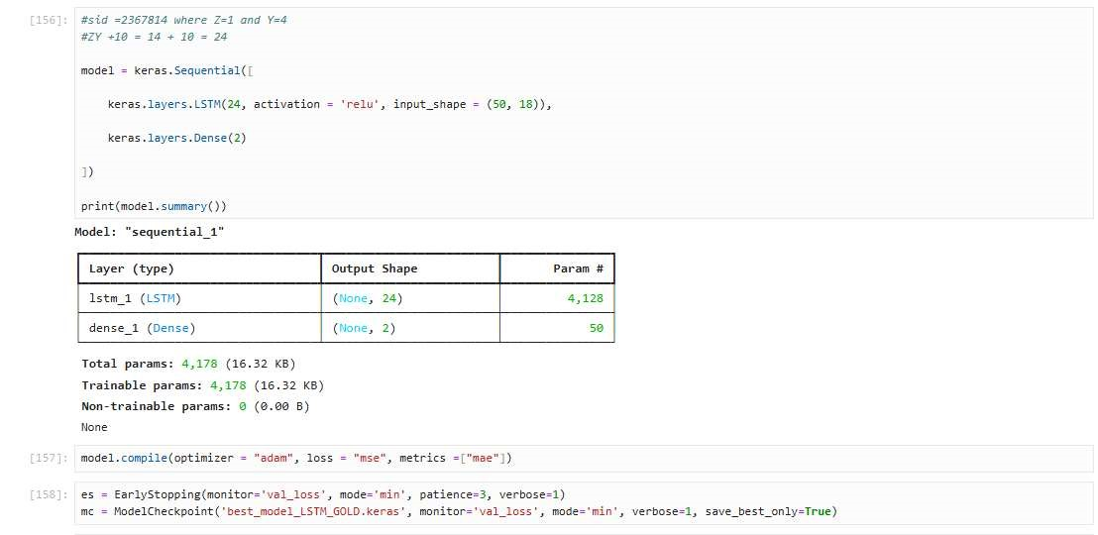

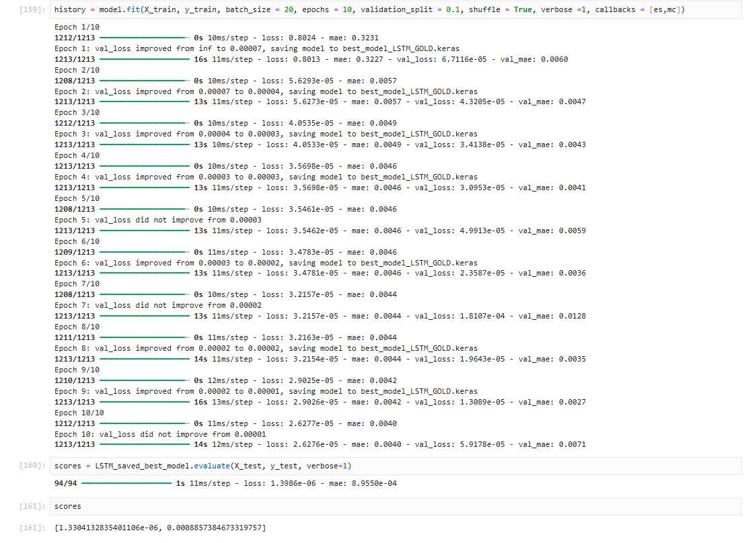

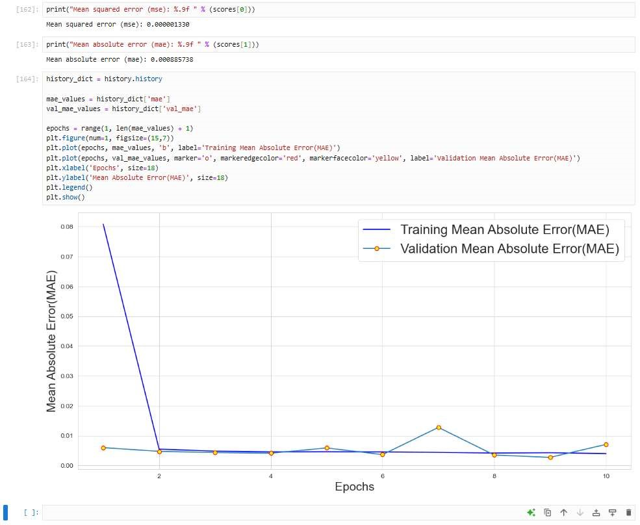

**Week-8 Logbook:**

**Week-10 Logbook:**

**Week-11 Logbook:**

